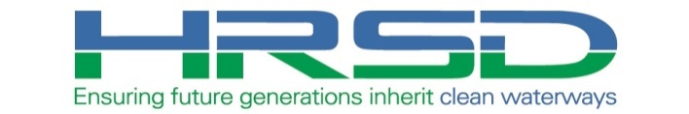

To all Stakeholders:

Construction of the HRSD Downtown Norfolk Pipeline Replacement project has begun/is ongoing.

Please use this link www.hrsd.com/subscriptions to be directed to the HRSD Subscriptions web page. From there, you can fill out the form to receive email notifications about the project when there is an update on the website. You can choose to be notified about a specific HRSD project, or you can choose to be notified about any HRSD project by selecting one or more localities.

Specific project areas scheduled for work will be notified via field distributed project flyers within one week of the actual work.

Should you have any questions or concerns, please feel free to reply to this email with your contact information and a project representative will contact you.

Thank you.

(Project Team Member,
email signature line, and contact info)

*Ensure that this email is going out as a Bcc to all parties
**Ensure that you have included all recent inquiring parties in and are maintaining the project’s-email distribution group (city partners, meetings, and citizen correspondence).

