Notice to Neighbors

Month Year

Public Project Name

HRSD, your regional wastewater treatment utility, in coordination with the City of Newport News, is planning a project in your neighborhood to replace the existing HRSD and City sanitary sewer pipelines and public sewer service connections that are nearing the end of their useful life. This replacement project will also improve the system’s performance and ensure continued, reliable sewer service in the future. The answers to some Frequently Asked Questions (FAQs) are provided on the back of this notice.

Project Overview
The project is located in the neighborhood surrounding Huxley Place from the Carnegie Drive intersection to the northern end of Huxley Place near City Center Boulevard and at certain locations along Alpine Street and Warwick Boulevard. This project includes pipelines, manholes, as well as some public water service and sewer service lateral pipes. Theses pipes will be repaired or replaced within the city right-of-way. The owner of any private sewer service pipe that is found in need of repair, will be contacted. The contractor will maintain a clean job site and minimize traffic disruption.
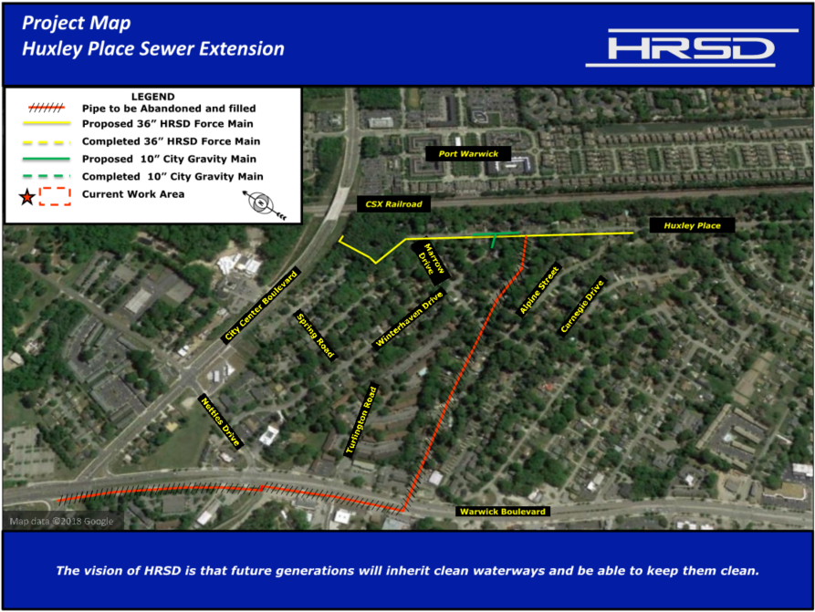
Project Schedule

Staging: September 2019

Construction:
Phase 1: (work within the public right-of-way along Huxley Place)
Fall 2019 – Fall 2020

Phase 2: (work within the public right-of-way along Alpine Street and Warwick Boulevard)
Fall 2020

Restoration:
Immediately following construction when seasonably appropriate

You also may visit www.hrsd.com/construction-status for additional information and project updates

If you have any questions, concerns, or comments about the project, please feel free to contact Lisa Bolen, HRSD Public Information Specialist, at 757.460.7000 or LBolen@hrsd.com.

Thank you for your support of this effort to help achieve HRSD’s vision: Future generations will inherit clean waterways and be able to keep them clean.

Why is this project necessary?
A. This project is a necessary to increase the reliability of the sewage collection system by replacing aging infrastructure and eliminating unvented high points in the existing sewer line.

Will the project affect the flow of traffic in the neighborhood?
A. Comprehensive traffic control plans will be implemented to minimize disruptions to the flow of traffic. There will be planned detours during some phases of construction. Signage will be placed prior to these detours.

Will access to properties along the route be maintained during construction?
A. The contractor will ensure that access to residences, and at least one entrance to businesses, will be maintained throughout construction. Trash and mail services will not be affected. If necessary, the contractor will move trash containers from within a work zone to an area accessible for pickup and will be responsible for returning them to each residence.

What are the general working hours for the project?
A. Work will typically take place Monday through Friday during daylight hours (8 a.m. - 4 p.m.). However, there may be times when extended hours, work at night, or weekend work may be necessary.

Will there be any interruptions to my water or sewer service?
A. Your sewer service will be temporarily interrupted if work is to be performed on the sewer lateral pipe that serves your property. The contractor will notify you before your lateral is to be replaced so you can plan appropriately. Sewer service typically will be restored within several hours. Your water service should not be affected by this project.

Will construction affect the existing pavement?
A. Where sewer and lateral pipes are dug up, asphalt, curb, gutters, driveway aprons, and grass will be removed and then restored upon completion of the project.

What sort of noise should I expect during construction?
A. The typical construction noises such as equipment engines, back-up alarms, materials being delivered, diesel generators, air compressors, sawing, etc. should be anticipated.

Will material and equipment be stored on-site?
A. It is anticipated that the contractor will negotiate with a private property owner for a storage area in the project vicinity, and this site will be used for most of the equipment and supplies. The contractor will keep some supplies within the active work zone, in the public right-of way.

Where will construction workers park?
A. Construction workers will not be allowed to park their personal vehicles on the public streets. However, work trucks will be allowed to park within the active work zone.

What is the cost of the project?
A. The estimated cost for the project is approximately $5 million and is financed by the wastewater treatment fees paid by HRSD ratepayers.

How can I receive regular project updates?
A. Regular project updates are posted on the HRSD website at www.hrsd.com/construction-status. You may also sign up at www.hrsd.com/subscriptions to receive an email notification whenever the website has an update about the project.

