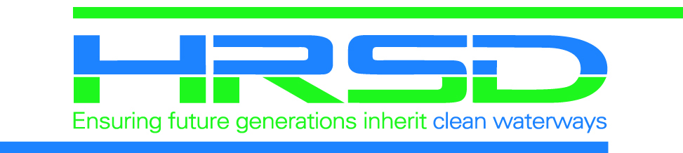
CONSTRUCTION NOTICE
UPDATE (#)
City
Month Year

Public Project Name
--Utility Work to Begin--

HRSD, your regional wastewater treatment utility, will begin work to install a sanitary sewer pipeline at the intersection of Orcutt Avenue and Mercury Boulevard. This work should take place primarily between the hours of 8 a.m. to 6 p.m., Monday – Friday.

Construction Update:
- Beginning as early as (anticipated work begin date), pipe installation work will begin in the vicinity of your home/business.
- This work will take place during daytime and predominately in the intersection.
- Be aware, traffic patterns will shift and will include partial street closures. Traffic control measures and detours will be in place.
- This work should not affect your water or sewer services.
- This portion of the work is anticipated to be completed in 3-4 weeks. Due to the nature of construction, work is weather and situation dependent and dates are subject to change.

While our project team works diligently to minimize impacts, you may notice increased noise, traffic, crews, and heavy equipment (with back-up safety alarms) associated with construction. Please take care when traveling around the construction area and for your safety, do not enter the site.

Please visit the project’s webpage for more information and updates:
www.hrsd.com/construction-status

Thank you for your support of this effort to help achieve HRSD’s vision:
Future generations will inherit clean waterways and be able to keep them clean.

Should you have any questions or comments, you may contact:

HRSD Public
Information Specialist:
Lisa Bolen
(757) 460-7000
lbolen@hrsd.com
HRSD Project Manager:
Name
Projects@hrsd.com

Onsite Inspector
(Emergent Concerns):
Name
(xxx) Cell Phone

