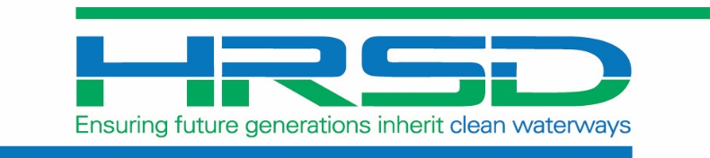
SMOKE TESTING
NOTICE
Month Year

Sanitary Sewer Testing to Begin
--City of Virginia Beach--

Smoke testing of the sanitary sewer system will take place within the XXXX neighborhood in the City of Virginia Beach from late October through December.

Testing along your street is planned between these dates:
___________________

(This schedule is situation and weather dependent)

This non-invasive test of the system does not require private property access and will usually take place
Monday through Friday from 7 a.m. to 5 p.m.,
unless in a school zone.

Please read the back of this notice for some tips and answers to some Frequently Asked Questions about what to expect during the Smoke Testing.

Frequently Asked Questions

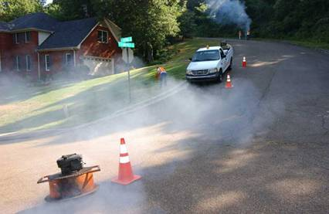
Smoke Testing

Q: Do I need to be at home during smoke testing?
A: No.

Q: What is the purpose of and how will the smoke testing be accomplished?
A: Smoke testing is used to find possible leaks in the sanitary sewer system. During this test, non-toxic, artificially created smoke (like a fog machine at a concert) is blown into access points (manholes) in the pipe. This smoke will escape through defects in the pipe, such as holes or cracks, or through illicit connections, such as roof leaders, and be visible above ground. Plumes coming from plumbing vents and manhole rims are normal. The plumes may be marked with flags, and defects will be noted. The plumes or markers may also be photographed. The fire department will be notified of smoke testing plans.

Q: What do I need to do to prepare for smoke testing?
A: When you receive notice that smoke testing will take place, you should check to see that all drain traps under sinks, toilets, washing facilities, and floor drains have water in them. To fill them, simply run each faucet for 30 – 60 seconds, flush toilets, or fill the drains with about 3 cups of water.

Q: What should I do if I have pets in the house and will not be home during smoke testing?
A: The smoke is not harmful to pets. It would be a good idea to leave several windows partially open for ventilation, should any smoke enter the building. If you have proper plumbing connections and all of the drain traps have water in them, there should not be any problems.

Q: Is the smoke harmful to humans or furnishings?
A: No. It may make you cough, but it is not harmful to your health and will not harm clothing, drapes, or furniture.

Q: What should I do if smoke gets into the house and how long will it take to dissipate?
A: If smoke enters your home during testing, please notify the contractor immediately, open windows to allow ventilation, and note the location of the smoke. Smoke inside your home can help identify bad plumbing connections or a cracked seal around a toilet. Smoke alarms may also sound. The smoke will clear within a few moments. The amount of time required will depend upon how much smoke enters the building and how much ventilation you can provide.

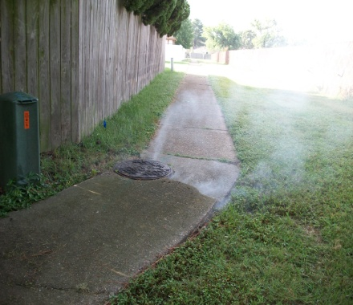
Q: Who will conduct these tests?
A: HRSD has retained Brown and Caldwell to manage the testing. Brown and Caldwell plans to use the services of Hydrostructures to conduct the investigative tests.

Q: Can smoke stop up the sanitary sewer?
A: No. The smoke is made up of a vaporous substance.

Q: What happens if HRSD finds a bad sewer connection or lack of traps in my home?
A: An engineer will review the investigation information and make a recommendation, which will be reviewed by HRSD staff and shared with you.

If you have other questions or concerns about smoke testing, you may call 757.460.7000 or send an email to Projects@hrsd.com.

