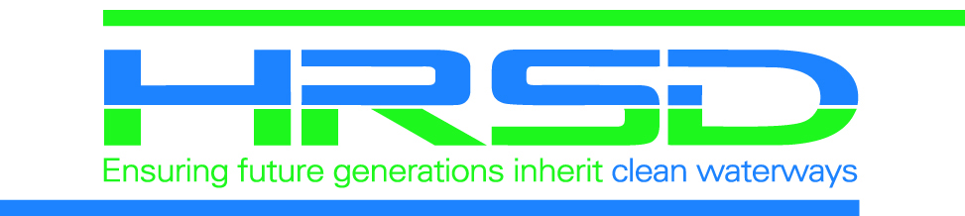
Unplanned Power
Outage Notice

Public Project Name

-UNPLANNED POWER OUTAGE-

The contractor for HRSD, your regional wastewater treatment utility, has experienced a downed power line.

Dominion Power has been notified of the issue and is onsite to repair the issue.

To find out estimated repair times, please call 866-366-4357 or check the outage map at www.dominionenergy.com/virginia/report-outage-or-emergency

HRSD would like to apologize for any inconvenience this may have caused and thank all the residents for their continued understanding and patience during this important sewer extension project fulfilling

HRSD’s vision: Future generations will inherit clean waterways and
are able to keep them clean.

