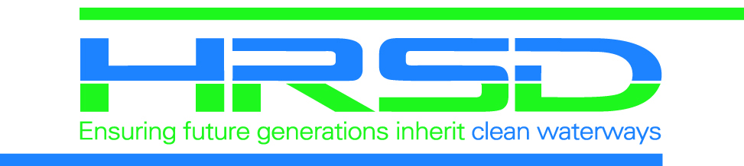
Unplanned Service Interruption Notice

Public Project Name

-UNPLANNED WATER SERVICE INTERRUPTION-

The contractor for HRSD, your regional wastewater treatment utility, is experiencing an unplanned occurrence that has caused a temporary water service interruption.

Newport News Waterworks (757-926-1000) has been notified of the issue and will be working to repair the issue.

HRSD would like to apologize for any inconvenience this may have caused and thank all the residents for their continued understanding and patience during this important sewer extension project fulfilling

HRSD’s vision: Future generations will inherit clean waterways and
are able to keep them clean.

Should you have any questions or comments, you may contact:

HRSD Public
Information Specialist:
Lisa Bolen
(757) 460-7000
projects@hrsd.com

Onsite Inspector
(Immediate Concerns):
Name
Number

