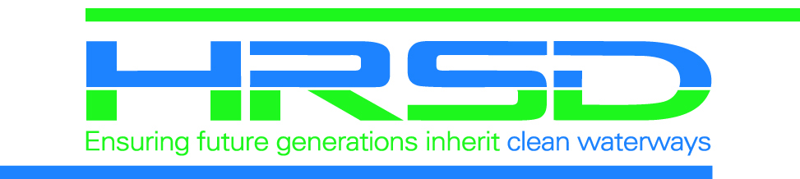
CONSTRUCTION NOTICE
City
Month Year

Public Project Name
-Project Completion Notification-

The contractor for HRSD, your regional wastewater treatment utility, has successfully completed pipeline construction work related to the sewer pipeline replacement projects in your area. Final landscape restorations will take place in the fall when the weather is more conducive to successful plantings.

As the newly installed pipeline is now in service, HRSD will fill the old pipeline with cementitious like material and will safely leave it in place to minimize additional disruptions. The contractor may need to access a few locations along existing easements to perform this work and will coordinate with those homeowners. This work should begin this week and is anticipated to be completed within two weeks.

HRSD maintains a one-year warranty period with the contractor to review items that may need to be addressed after final restoration. If you have any areas of concern, please let us know so these items may be addressed through this process.

HRSD would like to thank you for your understanding and patience during this important effort to help achieve HRSD’s vision:

Future generations will inherit clean waterways and are able to keep them clean.

Should you have any questions or comments, you may contact:

HRSD Public Information Specialist:
Lisa Bolen
(757) 460-7000
lbolen@hrsd.com

