Courthouse Pressure Reducing Station Project

Willingness to Hold a Public Open House

Project Overview: HRSD, your regional wastewater treatment utility, is planning to install a Pressure Reducing Station (PRS) at 2532 Nimmo Parkway. The facility, which will be across from the City of Virginia Beach Building Maintenance Facility (Building No. 9 in the City Municipal Center), will be designed to coordinate with the area’s architecture and screened from the view of Courthouse Marketplace by existing vegetation. Construction will have minimal impact on traffic, and our contractor will be required to maintain a clean worksite.

Need, Design and Schedule: The project is needed to maintain appropriate pressures in the sanitary sewer pipeline during wet weather and dry weather conditions and to ensure that the system has the capacity required to convey future wastewater flows. The plans call for the installation of pipe, valves and pumps along with a small structure to house electrical equipment and various appurtenances to function as a PRS. Attractive fencing and new landscaping will enhance the appearance. We expect to advertise for bids in August and award the contract in September 2013. Construction is expected to take nine months.

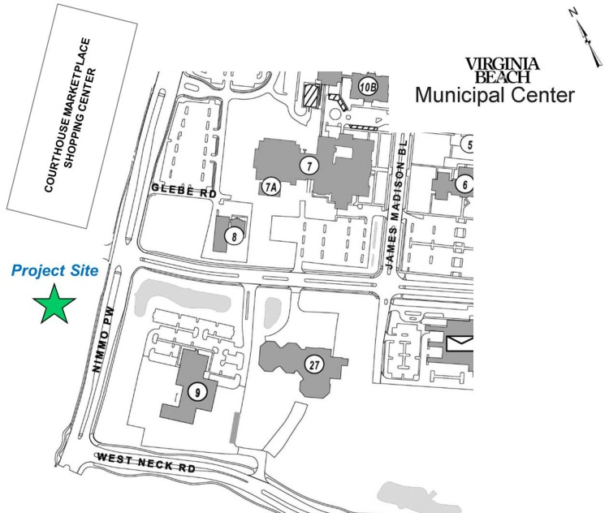

If you have concerns or comments about the project, want to review the plans, or desire for us to hold an informational public open house, please call the HRSD Public Informational Specialist at (phone number for corresponding PIS) or send an email to projects@hrsd.com

You also may visit www.hrsd.com/construction-status for additional information and project updates.

