August 24, 2021

Dear Neighbors:

In coordination with York County, HRSD, your regional wastewater treatment utility, invites you to attend an Open House to learn about the Tabb Pressure Reducing Station & Offline Storage Facility. HRSD is undertaking a project to construct the Tabb Pressure Reducing Pump Station & Offline Storage Facility, which will include constructing two 2.5-million-gallon offline storage tanks and a pressure reducing pump station. The new facility will be located on HRSD property located at 900 Yorktown Road in Yorktown and is designed to relieve pressures to the sewer system during wet weather events and provide flow balancing for HRSD’s James River and York River Treatment Plants. The facility will improve system operations, increase flow capacity, and provide reliable sanitary sewer infrastructure for your community and the region. Additionally, these system improvements are mandated by the EPA to reduce sanitary sewer overflows.

Representatives of HRSD will be available during the Open House to explain the project and respond to questions. Frequently Asked Questions on the back of this page provide more information about the project.

Project Open House
Date: Thursday, September 9, 2021
Time: Come at your convenience
between 5:00 p.m. – 7:00 p.m.
Place: Tabb High School Lobby
4431 Bethel Road
Yorktown, VA 23693

Come to the Open House at your
convenience and:
• Discuss the project with the project team
• See the project site possibilities and what the
facility may look like
• Ask questions

If you cannot attend the Open House, a pre-recorded video is available to view that includes slides, pictures, and narration with explanations from the project manager. You can view the video and submit questions at the following link: www.

Anticipated Project Schedule
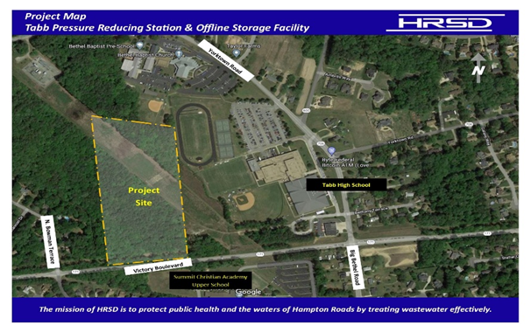
Design Completion: Summer 2022

Construction: Fall 2022 - Spring 2024

If you are unable to attend this open house and would like to obtain more information, please contact:

Lisa Bolen, HRSD Public Information Specialist
Phone: 757.460.7000
Email: projects@hrsd.com

What is the Tabb Pressure Reducing Station and Offline Storage Facility Project?
A. The Tabb Pressure Reducing Station and Offline Storage Facility will construct two 2.5-million-gallon offline storage tanks and a pressure reducing pump station. The facility is designed to relieve pressures to the sanitary sewer system during wet weather events and provide flow balancing for HRSD’s James River and York River Treatment Plants. The flow balancing is necessary to support the process needs of the Sustainable Water Initiative for Tomorrow (SWIFT) facility. For more information about SWIFT, please visit swiftva.com.

Why is a storage tank needed in this area, and what exactly is a storage tank?
A. During wet weather events, the above-ground storage tanks will temporarily hold the wastewater and rain/groundwater to relieve pressures to the sewer system. HRSD needs storage tanks in this area of York County to meet regulatory requirements. This location within HRSD’s sewer system offers significant benefits to York County and the region due to its universal (unmatched) connectivity within the HRSD pipe network. There is no other location within the HRSD system that allows for such a facility to manage system-wide flows from one singular location.

Will this prevent street flooding during hurricanes or other high rain events?
A. No. While the offline storage facility is being designed and built to handle increased flow during routine wet weather events, its primary role is not intended to collect or treat stormwater. The tanks are not sized to prevent all sanitary sewer overflows (SSOs) when named storm events (tropical depressions, tropical storms, hurricanes, etc.) or lengthy nor’easters occur. HRSD’s sanitary sewer treatment system operates separately from York County’s stormwater collection and treatment system.

How safe is this? What safeguards does HRSD put in place to ensure safety?
A. The proposed facility is very safe, with over 10,000 similar tanks constructed over the last 70 years. The tanks will be monitored and controlled remotely to observe levels within it and to make sure that they are functioning as designed. HRSD will perform routine internal inspections of the tanks to verify their condition, and maintenance will be scheduled based upon these inspections.

Will this storage tanks create odor issues for the surrounding community? What will do you plan to do to minimize or eliminate odor?
A. The storage tanks will not create odor issues. HRSD will install an odor collection and abatement system to treat the air in the tanks. Similar technologies have been proven effective with other HRSD pump stations, wastewater treatment plants, and other odor related facilities.

Will the construction disrupt traffic in the area or create excessive noise?
A. HRSD, the design team, and the selected contractor will be coordinating closely with York County to minimize impacts on traffic and pedestrians in areas near construction. County noise ordinances will be followed by identifying and dampening excessive noise-generating activities as well as vibration from equipment during construction activities.

What are the general working hours for the project?
A. Work will typically take place Monday through Friday during daylight hours (8 a.m. - 5 p.m.). However, there may be times when extended hours, work at night, or weekend work may be necessary.

Will there be any interruptions to my water or sewer service?
A. Your water service should not be affected by this project.

Will material and equipment be stored on-site?
A. Equipment and materials for this project will be stored on the project site within HRSD property boundaries and should not require any additional offsite storage.

Where will construction workers park?
A. Construction workers will park on the project site within HRSD property boundaries. Construction personnel will not be allowed to park their personal vehicles on the public streets.

What is the cost of the project?
A. The estimated cost for the project is approximately $22 million and is financed by the wastewater treatment fees paid by HRSD customers.

How can I receive regular project updates?
A. Regular project updates are posted on the HRSD website at www.hrsd.com/construction-status. You may also sign up at www.hrsd.com/subscriptions to receive an email notification whenever the website has an update about the project.

